Mediashippers Marketplace
Internal Marketplace Operations Documentation
STEP 2 — CORE METADATA & CONTENT STANDARDS

Reference Workflow Interface
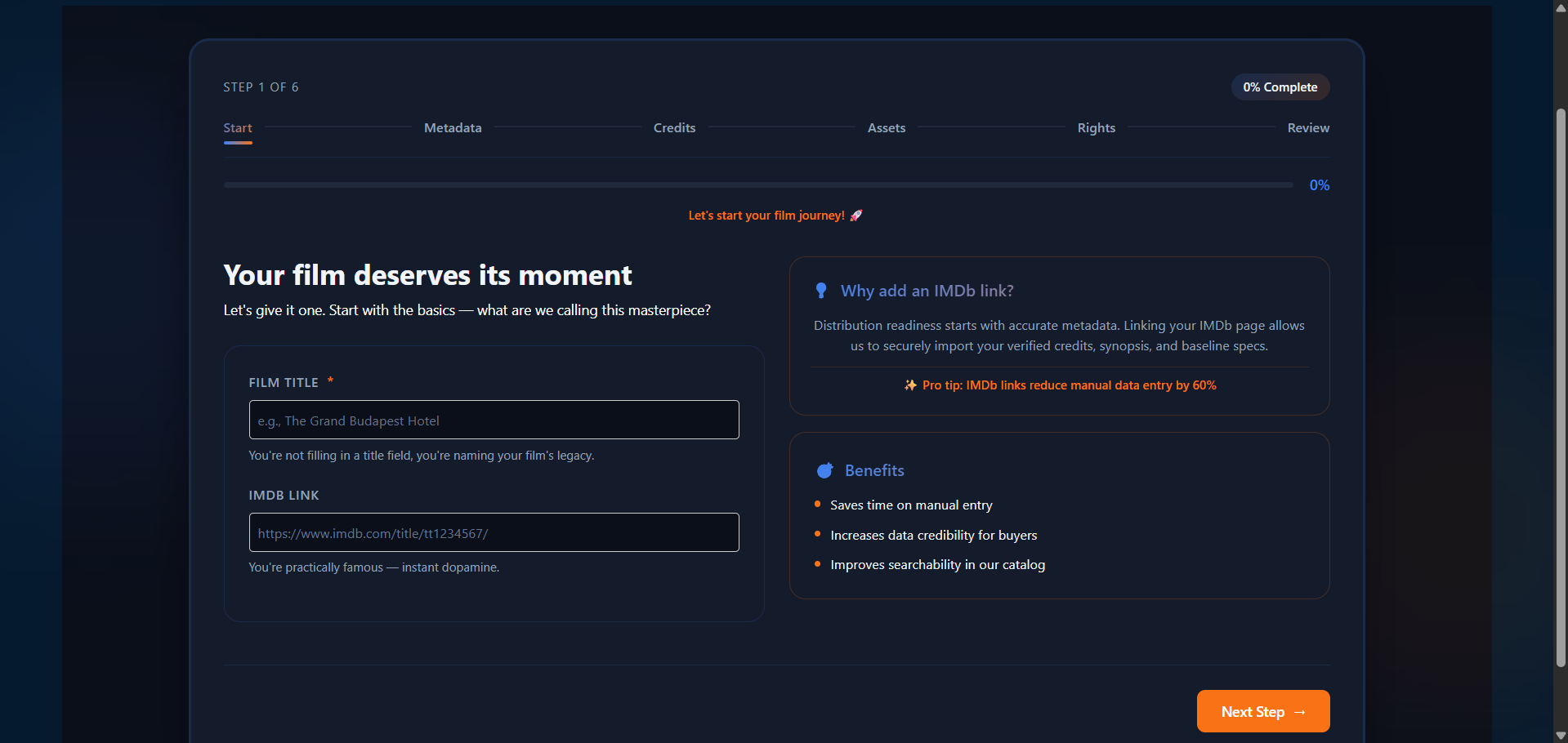
Figure 2.0 — Core Metadata onboarding interface used during marketplace content registration.

1. Purpose & Core Philosophy
The Core Metadata stage represents one of the most important layers of the Mediashippers licensing infrastructure. This module captures the descriptive identity of a title and transforms raw content into structured marketplace-ready metadata that can be indexed, discovered, filtered, recommended, and licensed across the platform ecosystem.
Metadata quality directly impacts how buyers discover titles, how recommendation engines prioritize content, and how rights-based licensing workflows are executed. To maintain marketplace consistency and professional presentation standards, all titles must comply with standardized metadata formatting and validation rules.

2. Marketplace Metadata Objectives
- Improve title discoverability across buyer dashboards
- Support AI-powered recommendation and matching systems
- Enable advanced filtering by genre, language, and rights availability
- Improve professional presentation quality for licensors and distributors
- Provide structured data for licensing analytics and reporting
- Support metadata-driven territory and rights discovery workflows

3. Core Metadata Fields
Field | Type | Requirement | Purpose
Short Synopsis | Text Area | Mandatory | Brief marketplace summary shown in search results.
Long Synopsis | Rich Text | Mandatory | Detailed story overview for buyer discovery pages.
Content Type | Dropdown | Mandatory | Defines title classification such as Film or Series.
Duration | Time Format | Mandatory | Specifies official runtime using HH:MM:SS format.
Genre | Dropdown | Mandatory | Supports recommendation and catalog classification.
Original Language | Dropdown | Mandatory | Primary spoken language of the title.
Dubbed Version | Boolean | Optional | Indicates whether dubbed versions exist.
Release Status | Selection | Mandatory | Defines whether content is released or unreleased.
Visibility | Selection | Mandatory | Controls public or private marketplace visibility.

4. Dummy Marketplace Metadata Example
The following example demonstrates how a professionally structured title entry may appear during onboarding.
Parameter | Example Value
Film Title | The Last Signal
Short Synopsis | A stranded astronaut intercepts a mysterious signal from Earth decades after humanity vanished.
Long Synopsis | Commander Elias Drake survives alone aboard a failing orbital station after Earth suddenly falls silent. Years later, a mysterious transmission suggests humanity may still exist beneath the planet’s surface. As systems collapse around him, Drake uncovers secrets tied to a hidden survival program.
Content Type | Feature Film
Genre | Sci‑Fi, Thriller
Runtime | 01:58:42
Original Language | English
Dubbed Versions | Spanish, Hindi
Release Status | Unreleased
Visibility | Public

5. Synopsis Writing Standards
Synopsis quality significantly influences buyer engagement and recommendation performance across the marketplace. Strong summaries improve content visibility and help acquisition teams quickly evaluate licensing suitability.
- Keep the short synopsis concise and engaging
- Highlight the primary conflict or emotional hook
- Avoid revealing major story spoilers
- Use clear, professional, and cinematic language
- Focus on what differentiates the title from similar content
- Avoid unnecessary production or marketing jargon

6. Supported Metadata Standards
All metadata entered into the Mediashippers platform must align with standardized content operations rules and category structures.
Supported Category | Example Genres | Typical Marketplace Usage
Movies | Sci‑Fi, Drama, Thriller | SVOD and TV licensing
TV Series | Crime, Comedy | Multi-season streaming distribution
Documentaries | Nature, Historical | Educational and factual licensing
Animation | Fantasy, Family | Kids and family distribution
Short Films | Experimental, Indie | Festival and curated platform usage

7. Validation & Compliance Rules
Before users may proceed to the Credits and Assets workflow stages, the platform executes multiple validation checks to ensure metadata integrity.
- Short synopsis cannot exceed 200 characters
- At least one genre selection is mandatory
- Original language selection is required
- Duration must follow HH:MM:SS formatting standards
- Visibility settings must be selected before progression
- Unsupported metadata combinations may trigger manual review
- Improper formatting or incomplete fields may reduce discoverability scores

8. Metadata & Buyer Discovery Impact
Marketplace metadata directly influences how titles appear inside buyer discovery interfaces. Recommendation systems, rights filtering engines, and regional licensing searches rely heavily on accurate metadata.
- Improves AI recommendation accuracy
- Supports genre and language filtering
- Improves discoverability during territory searches
- Increases buyer trust through professional presentation
- Supports catalog indexing and ranking algorithms

9. Workflow Progression
After successful completion of the Core Metadata stage, the onboarding workflow continues into the Credits configuration module.
- Start
- Metadata
- Credits
- Assets
- Rights
- Review

10. Internal Training Notes
This document is intended strictly for intern onboarding and internal workflow education purposes. All titles, metadata values, licensing examples, and descriptions used throughout this document are fictional and created solely for simulated marketplace training.
Interns reviewing this material should understand how metadata structure affects content licensing, recommendation systems, territory discovery, and professional buyer-facing presentation standards.
CONFIDENTIAL — MEDIASHIPPERS MARKETPLACE INTERNAL TRAINING DOCUMENTATION

